Game Design Document

Fill up the following document

Note: Ist part of game refers to the bee being chased by human and 2nd part refers to the good human being main character which has to stay away from bees.

1. Write the title of your project.

- The story of a bee.

1. What is the goal of the game?

-To educate people on the importance of bees.

1. Write a brief story of your game.

-The game will start off by a bee (playing character) being chased by a human ,the goal of the bee would be to collect 5 honey bottles and we will only get a bottle by answering to a question correct and if the human catches the bee ,we will show that soon bees would be extinct and that humans won’t be able to survive without bees if they keep on harming them as their would be no food produced and then we will be the good human and we would have to stay away from the bee’s and honey to protect them.There will also be random predators spawned which will try to harm the bees but we (good human)need to go near them and tell them to save bees.In case we miss one of the predators or touch the bees or honey we will loose a life.

1. Which are the playing characters of this game?

* Playing characters are the ones who respond to the user based on the input from the user.
* Cars, monkeys, dinos, wizards, etc., are the playing characters in the game.

|  |  |  |
| --- | --- | --- |
| Number | Character Name | What can this character do? |
| 1 | The main bee(1st part) | The bee can be moved with our mousekeys and its goal is to collect 5 honey bottles while staying away from the human. |
| 2 | The good human(2nd part) | This character will be able to move with our mousekeys and it needs to stay away from the bees and honey . |
| 3 |  |  |
| 4 |  |  |
| 5 |  |  |
| 6 |  |  |
| 7 |  |  |
| 8 |  |  |

1. Which are the Non-Playing Characters of this game?

* Non-Playing characters are the ones that don't have an action or behavior when the user interacts with the game.
* Hurdles, stones, bananas, coins, etc., are non-playing characters in the game.

|  |  |  |
| --- | --- | --- |
| Number | Character Name | What can this character do? |
| 1 | Honey bottles | They will randomly be spawned in the game and will move with a velocity.When a bee touches it in the first part of game a question will be asked and only answering it right the bee could get a bottle of honey. |
| 2 | Parasites | These will be in the first part of my game and will also be spawned randomly . |
| 3 | The predator (2ndpart) | This will also be spawned randomly and the human can loose a life if it moves pass it without telling it to stop harming bees. |
| 4 | Group of bees(2nd part) | These will act as obstacles to the good human. |
| 5 |  |  |
| 6 |  |  |
| 7 |  |  |
| 8 |  |  |

Draw your imagination of this game. What does this game look like?

* Draw the game either on your computer or on paper.
* Add images of the game scenes to show each of the playing and non-playing characters at least once.

First part of the game

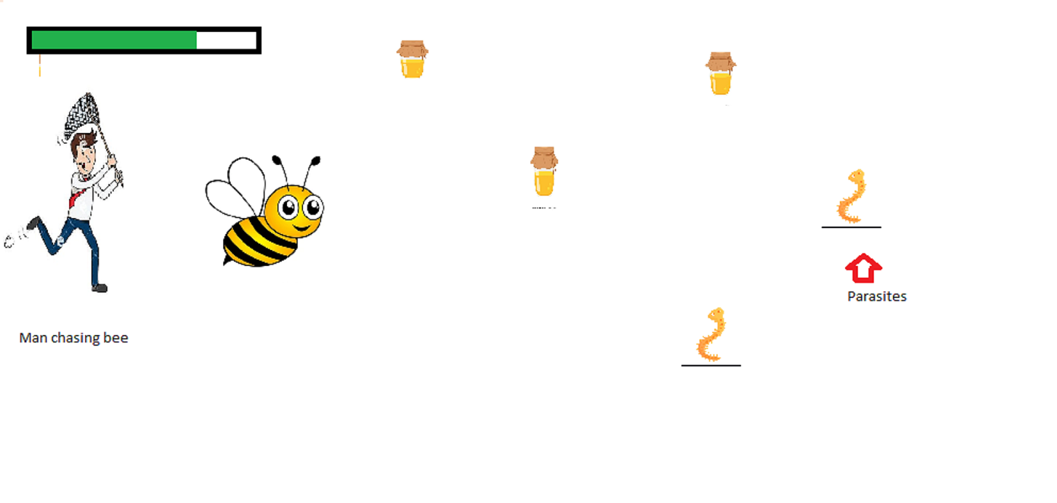**Second part of game**

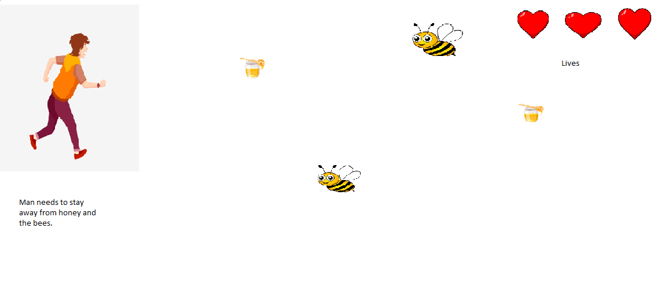

How do you plan to make your game engaging?

I am planning to make my game engaging by having questions before getting a bottle of honey and by having a energy level for the main bee(1st part) which will increase on getting a bottle of honey and will decrease on touching a parasite .The decrease and increase of energy level will decrease and increase the velocity of bee respectively.